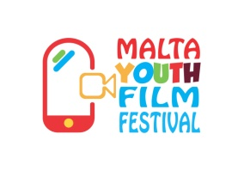
Second Edition

CONSENT FORM
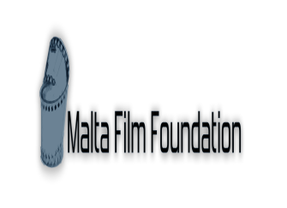

PERSONAL INFORMATION

In case of emergency, kindly contact:
NAME:
DATE OF BIRTH:
PHONE NUMBER:
RELATIONSHIP TO YOUNG PERSON:
ANY HEALTH ISSUES THE COORDINATORS NEED TO BE AWARE OF:
FOOD ALLERGIES:
PARENTAL CONSENT (For applicants under 18 years)

Tick if you consent to applicant’s participation in the Malta Youth Film Festival – Second Edition
Tick if you consent that audio-visual material generated during the Malta Youth Film Festival – Second Edition can be used for promotional purposes with regards to this programme

SIGNATURE OF PARENT/GUARDIAN: __________________ DATE: _________________________

CONSENT (For applicants over 18 years)

Tick if you consent that audio-visual material generated during the Malta Youth Film Festival – Second Edition can be used for promotional purposes with regards to this programme

SIGNATURE: _______________________________ DATE: ___________________________

